\



**Target audience:**

**MRI Technologists**

[www.MRICTreview.com](http://www.MRICTreview.com)

**Stephanie Cannon,**

**(R.T.) R MR M CT, ARRT**

**(R)(MR)(M)(CT)ARRT**

# 

# MRI Prostate Imaging

# and Breast Imaging

# November 9th 2019 Saturday

# 8:00 – 4:00 AM

**EMORY UNIVERSITY**

**MIDTOWN HOSPITAL**

**550 Peachtree St. NE**

**Atlanta, Ga. 30308**

**1364 Clifton Road**

**Atlanta, Ga. 30322**

**Sponsors:**

**We would like to acknowledge the support of:**



**Southern Girl Gifts**

**Hitachi Medical Systems**

**East Coast Medical Systems**

**SpinEchoMRI.com**

**Medical Technology Staffing, Inc.**



[**www.MRICTreview.com**](http://www.MRICTreview.com)

**(Medical Technology Staffing, Inc.)**

**Carolyn L. Brown, R.T. (R) (MR) (ARRT)**

**Snacks & food provided by our sponsors.**

**We are dedicated to offering the MRI technologist a simple and practical way to gain more understanding & education in the field of Magnetic Resonance Imaging Technology**

**Any Questions**

**Hostess Carolyn Brown, RT R MR**

**Email:** [**mrigal63@gmail.com**](mailto:mrigal63@gmail.com)

**(404) 375-0027 cell**

**Visit:** [**www.MRICTreview.com**](http://www.MRICTreview.com)

PayPal **on the web site.**

**Valet parking $8.00**

**Other parking close to hospital**

**Attention: MRI Technologists**

8 Category "A" ECU Credits

Limited seating

RSVP 404-375-0027

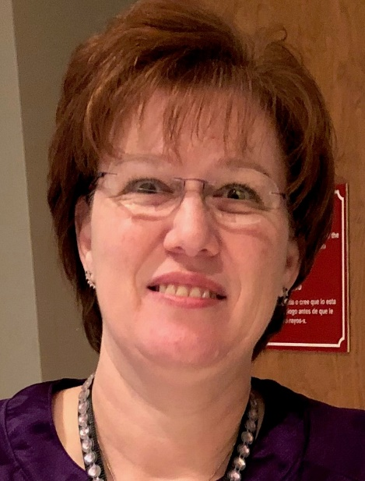

Stephanie Cannon, R.T.(R)(M)(CT)(MR)

Stephanie has been in the field of Radiology for more than 25 years. She has worked in Radiology, Mammography, Computer Axial Technology, and Magnetic Resonance Imaging.

Registered in multiple specialties and having worked in the out-patient, in-patient and applications settings over my 25+ year career has given her a broad appreciation for radiology. She loves the challenge of obtaining the highest quality images while providing superb patient care. Stephanie has also been an application tech. at Invivo Corporation (a division of Philips Healthcare. Check out her web page <http://www.southerngg.com>. She has MRI lanyards and etc for sale. Non ferrous

**AGENDA For November 9, 2019**

**7:30AM-7:55AM**

**Registration & Coffee and Donuts**

**Welcome and Announcements**

**8:00AM-9:50AM**

Prostate Anatomy & Pathology

***9:50 -9:55 BREAK***

**9:55-11:45 AM**

Prostate Imaging

***11:45AM*** *–* ***12:25PM Lunch***

***DONATED FROM OUR SPONSOR***

**12:25PM-1:40PM**

Pharmacokinetics *

Prostate Biopsy

***1:40PM-1:50PM BREAK***

***1:50PM-2:15PM***

Prostate Cancer Treatments *

**2:15 PM-3:05 PM**

Breast Anatomy & Pathology*

Breast screening and patient care*

**3:05PM-4:45PM**

Breast Imaging

Breast Biopsy

**\*25 min lecture**

**Registration Information**

**FILL OUT AND MAIL :**

Name___________________________________

Facility___________________________________

Address__________________________________

________________________________________

City_____________________________________

State___________________Zip______________

Phone___________________________________

Fax_____________________________________

Email____________________________________

**Registration Fee $135.00**

**Can pay with PayPal on my web site** [**www.MRIctreview.com**](http://www.MRIctreview.com)

**RSVP LIMITED SEATING**

**\*\*Refund with 48 hr. Notice\*\***

**All checks should be made payable to:**

**Medical Technology Staffing, Inc.**

**Fed ID# 58-2618129** [**mrigal63@gmail.com**](mailto:mrigal63@gmail.com)

**Carolyn Brown 761 Moss Side Drive Bethlehem, GA 30620-2576**

**Phone (404) 375-0027**

A confirmation e-mail will be sent to you upon receipt of payment.